Project Functional Specification

ENEL 387 Project

Name: Jiaan Nie

SID: 200327281
Table of Contents

1. System Information

1.1 Description---------------------------------------------------------------------------------------------------1

1.2 Block Diagram----------------------------------------------------------------------------------------------2

1.3 State Diagram-----------------------------------------------------------------------------------------------3

2. Operation

2.1 Commands---------------------------------------------------------------------------------------------------4

1. System Information

1.1 Description
There are few main sections to this project, first is that is Discord server. The purpose of this server is allowing anyone with permission to join and sends predefine commands to the bot created via python script. Next if the Raspberry Pi Zero, the pi itself is connected to the internet and it is also the host where the discord lives in and listening incoming commands from the discord server. Lastly is the physical mini robot car is being controlled by the STM32 board using in the ENEL 387 class.
The purpose of this project is allowing any users that has permission to join the discord server and controls the physical mini robot car via by sending predefined commands to the discord bot.
1.2 Block Diagram
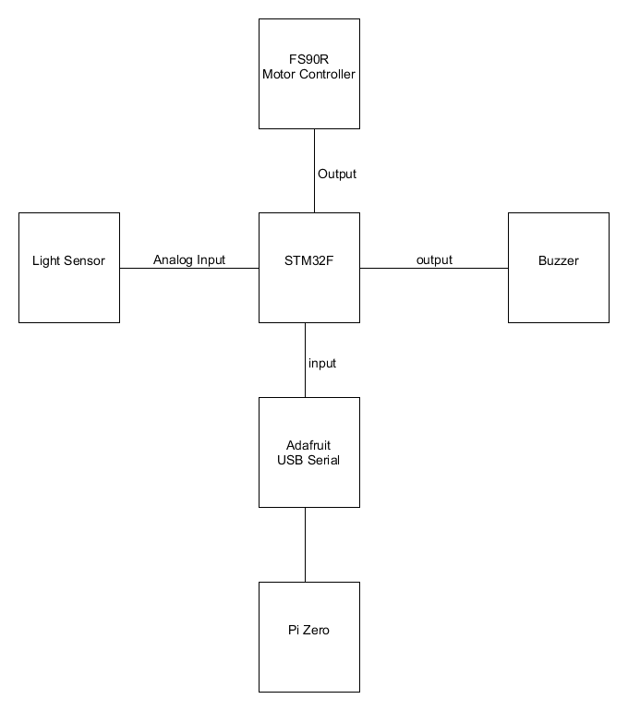
Figure 1

In figure 1 is the block diagram of the project, There are two brains in this project the STM32 and the Pi Zero, the Pi does most of the heavies lifting in term of connecting to the internet and hosting the discord bot or any networking related issues. On the other hand the STM32 board its responsibility is to controls all the hardware components, such as motors, led, buzzer etc...
The adafruit is used to communicate between the Pi and the STM32 board via serial communication. Whenever users in the discord server sending a command to the discord bot then the bot will send that command via serial communication to the STM32 which is controlling the mini robot car.

1.3 State Diagram
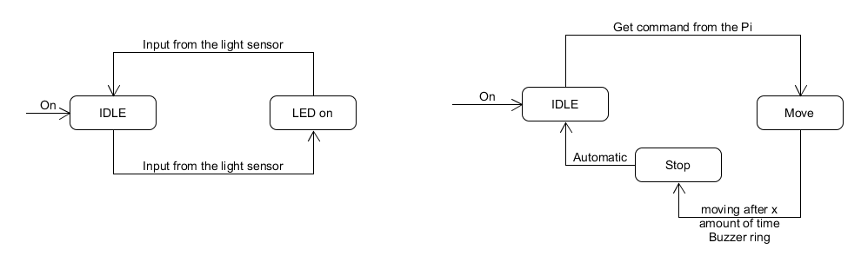
Figure 2
In figure 2 is the state diagram of how the project behaviour when is being powered, there are two independent states, on the left hand side, LED on and off state is based on the surrounding environment brightness, if the the surrounding is dark enough, the Led will turning on or if is bright the LED will remain off.
The second state diagram on the right hand side is based the command received from the discord bot, Once users send a command to the discord bot, the discord bot will pass the command to the STM32 board and control the motor accordingly or translate from idle state to move state. After moving x amount of time the buzzer will buzz, which is the indication or flag for translating from move to stop state. After the robot move to the stop state it will autocratically goes back to the idle states wait for the next command.

2 Operation

2.1 Commands
There are 4 basic command, will be implemented into this project which are the following commands: up, down, left and right. Those are the command that users can send it to the discord bot, once user type one of those command it will wake the discord bot up and it will start executing the function based on the command.

